Contents

Analysis 4

Intro 4

Research 4

History & Variations: 4

Rules: 6

Graphics: 7

Summary 8

Queue Diagram 9

Investigation of Limitations 10

End Users: 10

Interview 11

Requirements: 11

Limitations: 12

Modelling 13

Data Dictionary: 13

Design 15

Mock- Up Pages 15

Menu and Board Object Data Tables: 16

Code to display the Menu & Board 17

System Flowchart 19

Play Game Function Flow Chart 19

Sweet Class Diagram 20

Code to run board from file for 21

Preparation for Testing 21

Pseudocode 23

Pseudo Match and Check Matches Function 23

Pseudo For Queues 24

Code Log 25

V7 – Select P1 & P2 19/07/19 25

V8 – Make pieces move 25

V9 – Generate Board with no Matches 26

V15 – When background Matches are bigger than 3 in length need to leave the appropriate special sweet 26

Testing 27

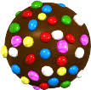Analysis

* *Attract people to do CS*
* *Games on the website*
* *Code a prototype*
* *Survey some year 11*
* *Interview Mr Tibble*

Intro

The aim of this project is to code a prototype of Candy Crush for the school website in order to make the Computer Science course more appealing to the Year 11s, among whom Candy Crush is very popular. For my research, I will need to survey some Year 11 students and interview Mr Tibble to devise the requirements for my version of the game.

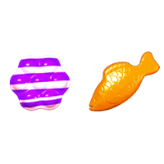

* *End Users*
* *Client requirements*
* *Different Versions*

## Research

History & Variations:

Candy Crush in its most basic principles is a match 3 game- there are thousands of variations of these, the most well-known, rising in 2012, being Candy Crush. It’s predecessor “Bejeweled” was also extremely popular as “It has been played by more than 500,000 million people around the world and consumed an estimated 10 billion hours of play since 2000 according to PopCap its maker”1 and some would argue that Candy crush owes its success to Bejeweled.

Bejeweled started off as a remake of an even older, much simpler game called “The Colours Game” which had the same rules but comprised of squares with no sound and the user had to refresh the screen after every swap. “Diamond Mine” as it was called then, was rented to Microsoft where it took the name Bejeweled.

It is likely that the earliest match 3 game was in fact originally a Russian computer game from the early 1990s by the name of “Shariki”, or “the balls”1

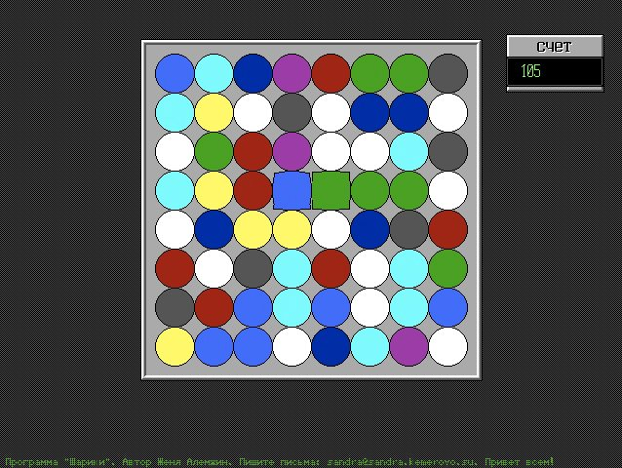

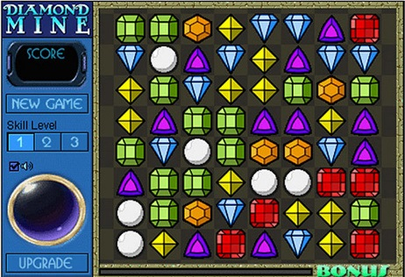

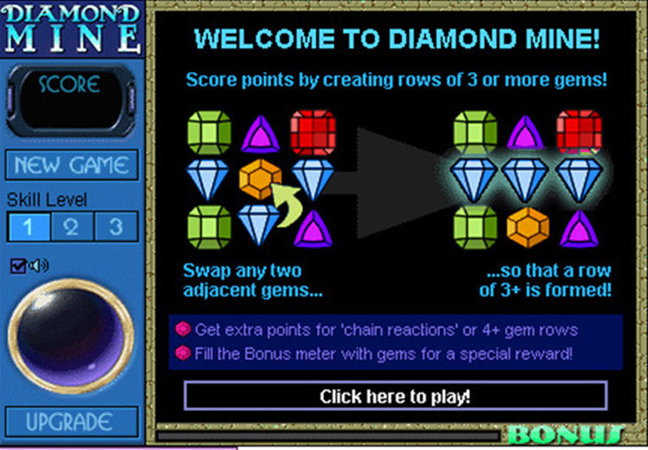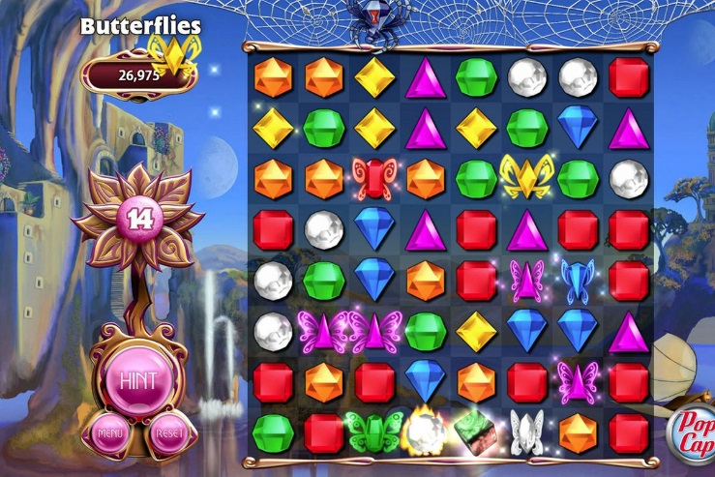

Since the invention of the iPhone & Android devices, mobile gaming has become a lot more accessible and allowed hundreds of different variations of the game to be produced, all where two adjacent tiles need to be swapped to create a row/column of at least 3 of the same tile. Another called “Homescapes”, uses household items and allows you to build your own house as the levels develop.

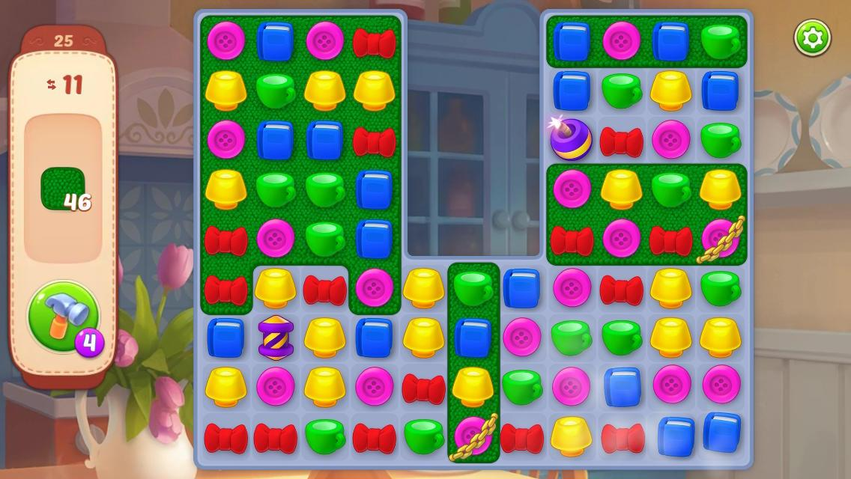

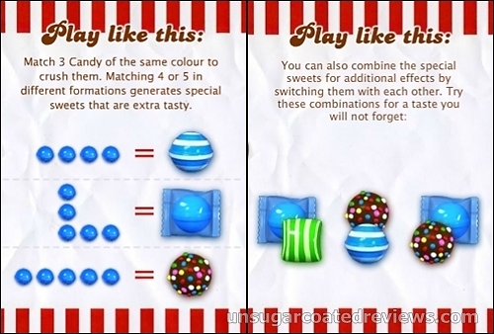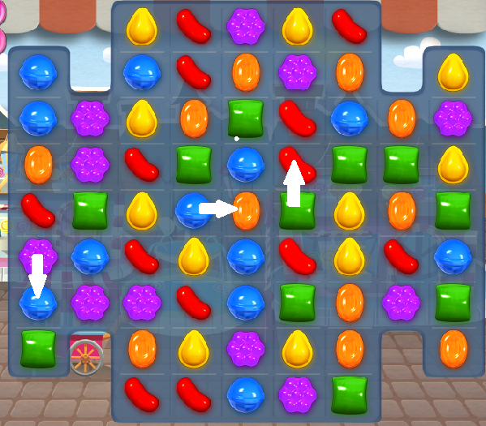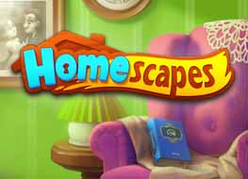

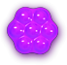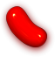

### Rules:

For the game Candy Crush, you swap two sweets to match 3 or more of the same sweet to get points. Matching more than 3 sweets or matching in a formation unlocks special sweets that have more destructive power and so allow the player to earn more points.

The points system works as the following:

* If 3 sweets are matched- get 60 points (the 3 sweets disappear random sweets above fall to fill space)
* If 4 are matched get a striped sweet- get 120 points (3 sweets disappear and the striped sweet remains)
  + The stripes are in the direction of the sweets swapped so either vertical or horizontal- when stripes are matched with their original kind, they blast all the sweets in their path either in their row or column
* If 5 sweets are matched- get a colour bomb + 200 points
  + Swapping a colour bomb with any other sweet, causes the colour bomb to destroy all of that type of sweet on the board- get 1200 points + 60 for every candy destroyed
* Making a wrap – get 200 points (L shape gives a wrapped sweet)
  + Matching a wrap gives 540 points plus 60 for each candy destroyed in a 3x3 grid

Combos:

* If a wrap is swapped with a stripe it also destroys all the columns and rows of the 3x3 grid

Blockers:

* Each jelly square is worth + 1000 points
  + The sweets appear on top of a jelly square and in order to get rid of it you need to make a match on top of it- They are often layered, so require more than one match
  + Making a colour bomb on a jelly will give you 6120 points
* For Liquorice- you have to make a match in the square next to it for it to be destroyed- gives 20 points each, Liquorice does not match with anything

Goals for Each Level:

* Limit the player, goal is to achieve a number of points within a number of moves
* Destroy all the jellies within a certain number of moves
* Get the ingredients to the bottom (Cherries & Hazelnuts)
* The more variety of sweets there are the harder the level

### Jelly fishGraphics:

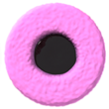Standard Candies-

* red jelly bean, striped/wrapped
* orange oval, striped/wrapped
* 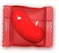yellow drop, striped/wrapped
* green square, striped/wrapped
* blue planet, striped/wrapped
* purple flower gummi, striped/wrapped

Special Candies:

* Jelly Fish – creates 3 Jelly Fish that target and eat one random candy each (preferring squares with Jelly), activating special candies if targeted­­­­­ 2
* Pink Coconut wheel with liquorice centre- when swapped with regular candy, continues on in that direction, clearing the first candy & converting the first 3 candies to striped candies. Once roll has finished, the striped candies will activate.2



Blockers:

* Chocolate
  + Prevent candy from filling that space
  + Grow across the board
  + Destroyed when there is a match next to it
* Multi-layered Icing
* Cages

Sound Effects:

When the user or a conveyor belt generates a cascade of 5 or more matches, Mr Toffee can be heard saying “Sweet”, “Tasty”, “Delicious” and “Devine”.2

## Summary

I am making a prototype of Candy Crush called, (Sweet Stake) which is a popular match 3 game, for Mr Tibble to put on the school websites to attract the year 11s to do Computing.

My game requires me to use:

* Queues
  + Queue Operations
* Classes as a - Complex User-defined use of object-oriented programming (OOP) model
* Dynamic generation of objects
* List Operations

## Queue Diagram

The Queues are needed for refilling of the board and hence there are 9 Queues, one above every column with 9 sweets in each in case the entire column is cleared (as in the event of a striped reaction).

Q1 Q2 Q3 Q4 Q5 Q6 Q7 Q8 Q9

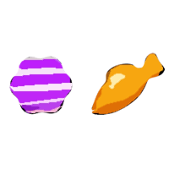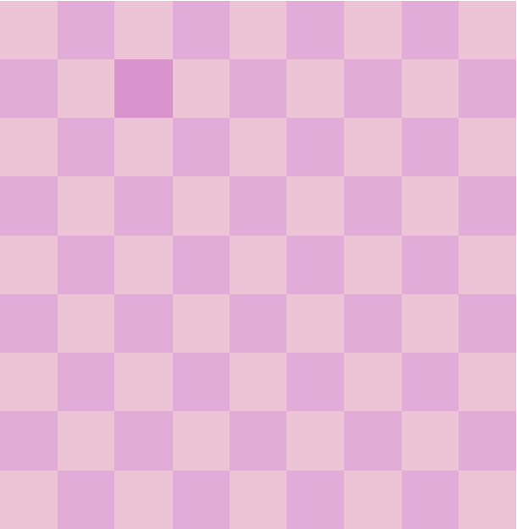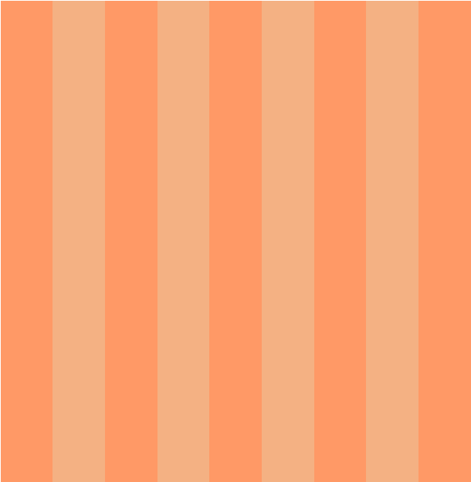

When there is a match here the matched sweets disappear and the sweets above fall down into the empty cells- Sweets from the Queue of that column also fall down as needed to fill the gaps and the empty cells in the queue are randomly regenerated.

This is the board the player sees

These queues are hypothetical, they are not actually displayed but if they were this is what they would look like

## Investigation of Limitations

### End Users:

To determine which features of the game the year 11s like, I sent out a survey: <https://s.surveyplanet.com/yRuTsAjMX>

The results that I will pitch to the client show:

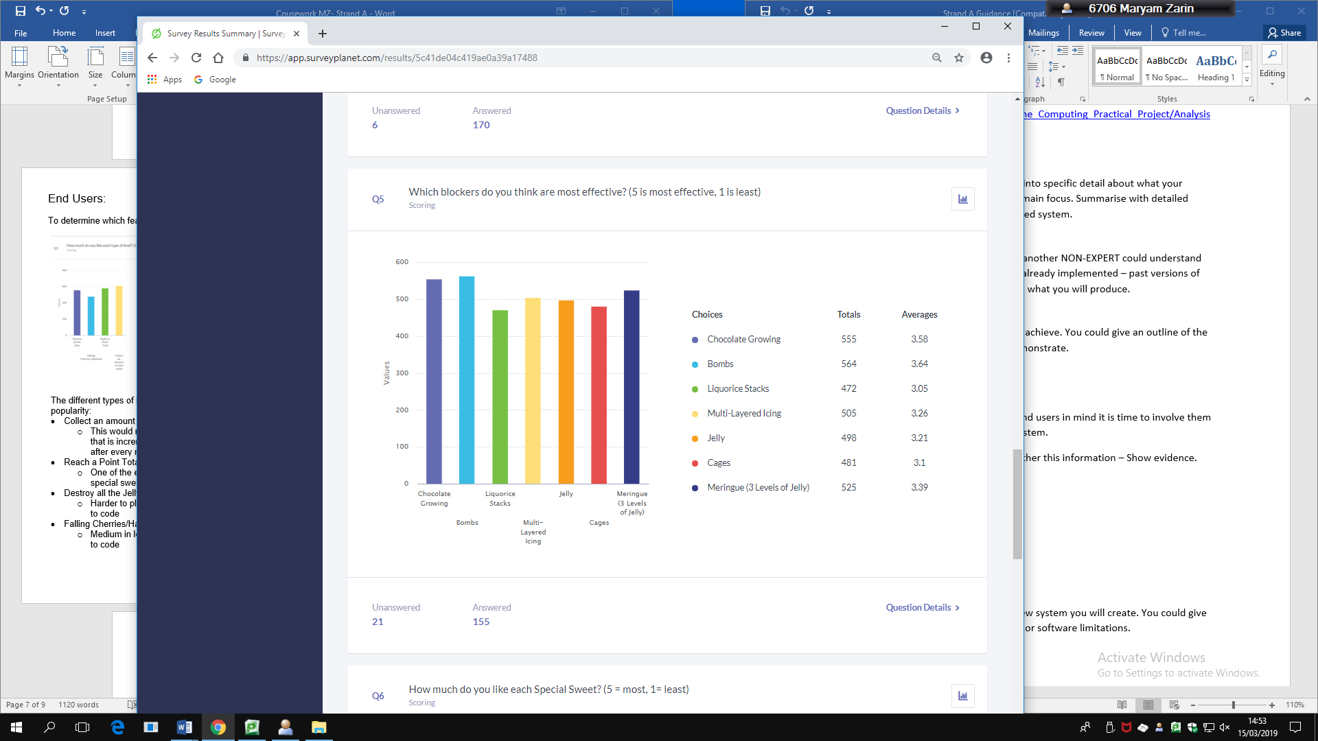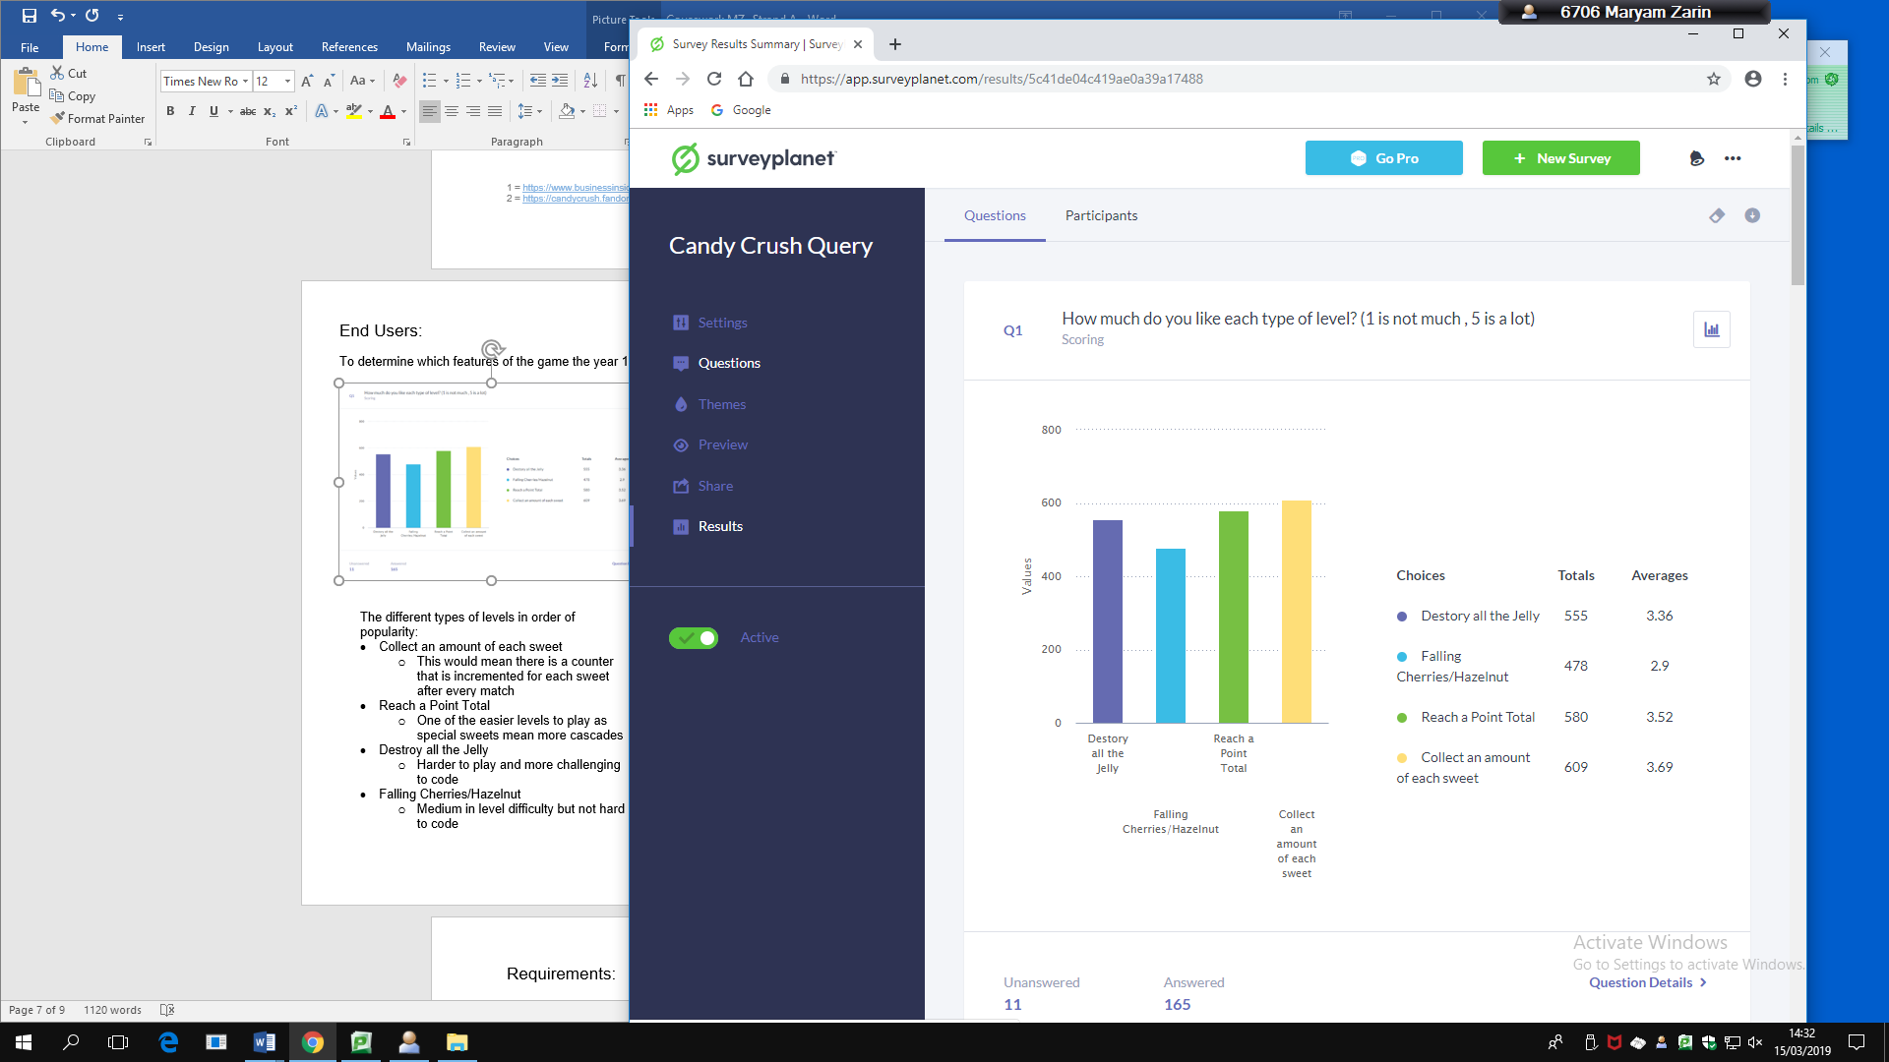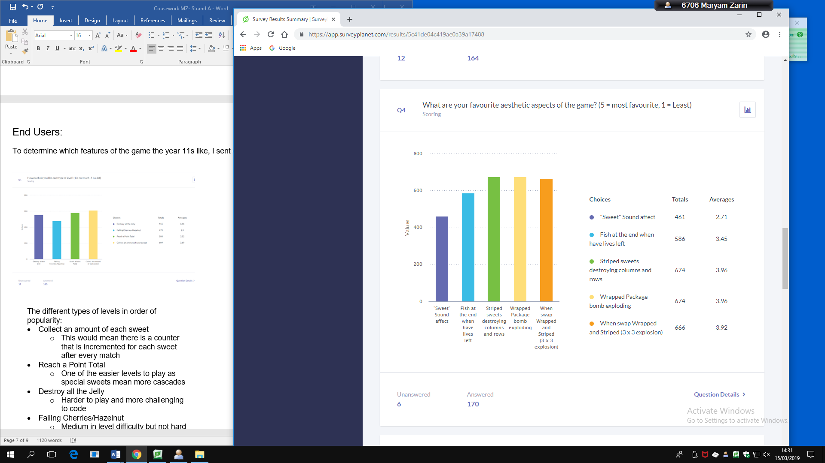

The most popular aesthetic aspects of the game are the striped sweets destroying rows or columns of sweets at once and a wrapped sweet destroying a 3X3 square, both of these effects will be difficult to replicate, however the effect in essence is possible and definitely something I want to incorporate into my version.

Swapping a wrapped and striped has a very similar impact to what is mentioned above.

Then it is the fish that are deployed at the end when the player has reached the target and still has moves left, this is an interesting concept, however is not a key feature so I do not feel it is necessary to include this.

On the other hand, the sound effects are very memorable and I would like to implement them

The different types of levels in order of popularity:

* Collect an amount of each sweet
  + This would mean there is a counter that is incremented for each sweet after every match
* Reach a Point Total
  + One of the easier levels to play as special sweets mean more cascades
* Destroy all the Jelly
  + Harder to play and more challenging to code
* Falling Cherries/Hazelnut
  + Medium in level difficulty but not hard to code

The bombs and the growing chocolate are the most effective types of blockers but also make the game much harder and so would be useful to add to my prototype.

The jelly is likely more well known by players and can also make for a more difficult game.

### Interview

Items to discuss during the interview with Mr Tibble:

* Survey Results
* Requirements- Input, Output, Aesthetic & Process
  + Which blockers, special sweets, Level types
  + Sound effects
  + High Score board
* Any suggestions

The key points from this interview were:

* Have a demonstration of queue system behind the scenes- so there should be an option at the top of the board to see which sweets will drop down in the next row.
* Candy objects should use inheritance e.g. have a class = candy others inherit from it
* Focus should be on the different candy types rather than the blockers. Perhaps one/two key blockers and aim for the different candy types + special ones.
  + Aim for 4 candy colours followed by Wrapped Sweets, H stripe, V stripe for the prototype.
* Levels can be randomly chosen and dynamically created.
* Could you have the option to load a board for testing? - Admin board to load for test

### Requirements:

From the interview and the survey, I have compiled a list of requirements that I will aim to fulfil.

Input:

* Menu- Select an option
* Select First sweet to swap
* Select Second Sweet to swap with

Output

* Highlight Button Selected
* Display Board
* Show sweets swapping
* Show sweets matching & disappearing
  + If there is a special sweet the sweets should match/ be destroyed according to the pattern of the sweet
* If applicable, show special sweet falling to fill a space
* Show cascade of sweets falling to fill empty space

Aesthetic

* 4 different versions of each sweet type- Original, vertically striped, horizontally striped and wrapped
* Sweets need to be seen swapping and falling to fill
* When matched there should be some sort of explosion
* When the colour bomb gets rid of one type of sweet there should be some sort of spark outwards from the colour bomb to the chosen sweets

Process

* Needs to know if the move is a match of 3, 4 or 5
* Needs to know if the move is an L match
* Needs to know if the match has a special sweet in it- then carry out the special destructive pattern for that specific sweet
* Have a Suggest a move- looks for a potential match on the grid and highlights the sweet
* If it detects no possible moves- reshuffle?- or the game ends

Sweet Types

* red jelly bean, striped/wrapped
* orange oval, striped/wrapped
* yellow drop, striped/wrapped
* green square, striped/wrapped

Blockers

* Jelly
* Chocolate

Could choose probability wise which type of board to load:

* Liquorice stacks
* Jellies on screen
* Falling food

### Limitations:

* I am using the Candy crush sweets, however they act as place holders as ideally they would be replaced with my own sweets, however due to the shortage of time this is not possible
* If the board detects no more moves possible-
* No special power ups like the ability to swap the position of 2 sweets without matching

Bibliography for research

1 = <https://www.businessinsider.com/the-history-of-bejeweled-2014-2?r=US&IR=T> - 26/01/2019

2 = <https://candycrush.fandom.com/wiki/Candies> - 26/01/2019

## Modelling

### Data Dictionary:

Candy Class Data Table:

|  |  |  |  |
| --- | --- | --- | --- |
| Variable Name | Data-type | Validation | Other comments |
| Colour | String | Red, Blue, Green , Yellow, PinkLiqu, Bomb, Chocolate |  |
| Row Position | Integer | 1 to 9 |  |
| Column Position | Integer | 1 to 9 |  |
| Stripes | Boolean | True or False |  |
| Stripes Direction | String | Vertical or Horizontal |  |
| Wrapped | Boolean | True or False |  |
|  |  |  |  |

Board Class Data Table:

|  |  |  |  |
| --- | --- | --- | --- |
| Variable Name | Data-Type | Validation | Other Comments |
| NUMROWS | Integer | 9 |  |
| NUMCOLUMNS | Integer | 9 |  |
| CandyPic | File |  |  |
| JelBoard | Array | 2-D | For the jelly |
| SweetBoard | Array | 2-D | Which sweet is where |
| Jelly | Integer | 1 to 3 | How many Layers |
| Points | Integer |  | Points total from matches |
|  |  |  |  |

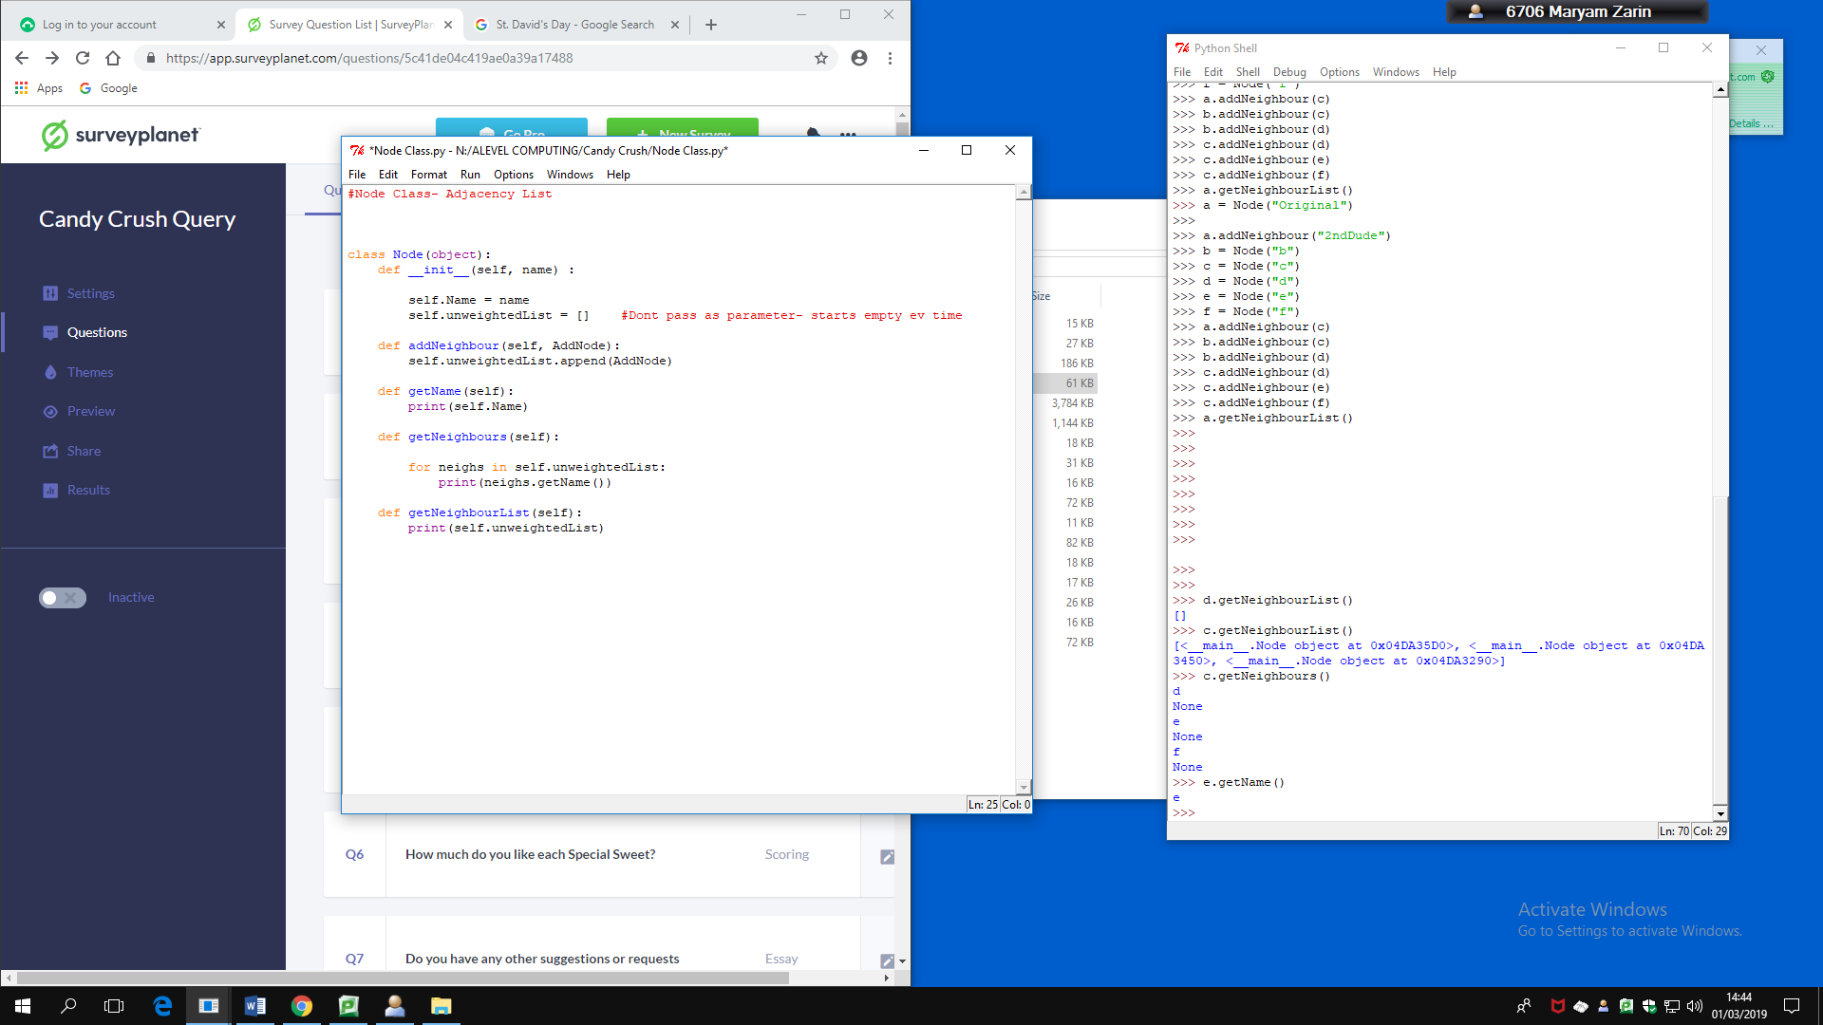

This code may be useful in the design or coding phase to create a class for the sweets later on

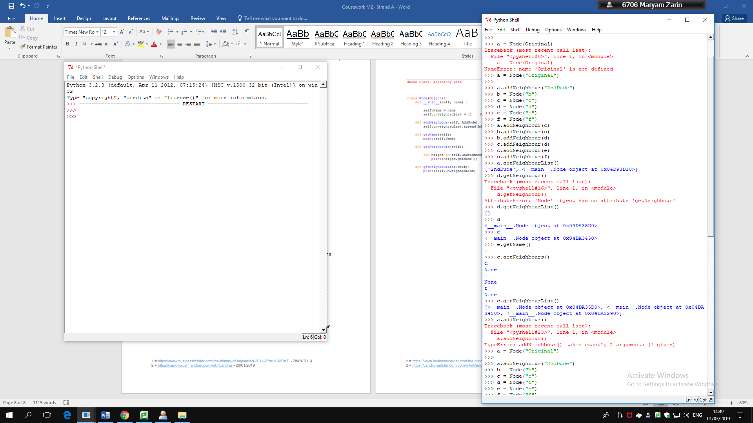

Design

* *Do Mock Ups of 2 screens*
  + *Menu*
  + *Game board*

## Mock- Up Pages



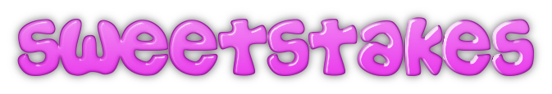Using the website: <https://cooltext.com/Logo-Design-Easy>

Game Menu

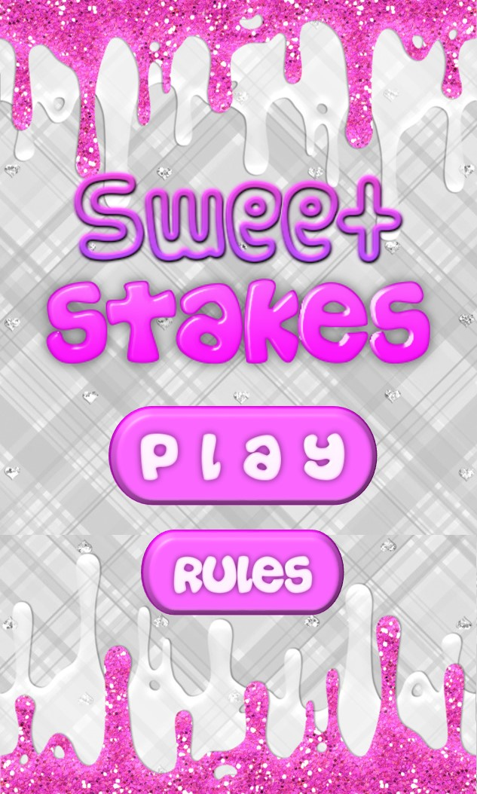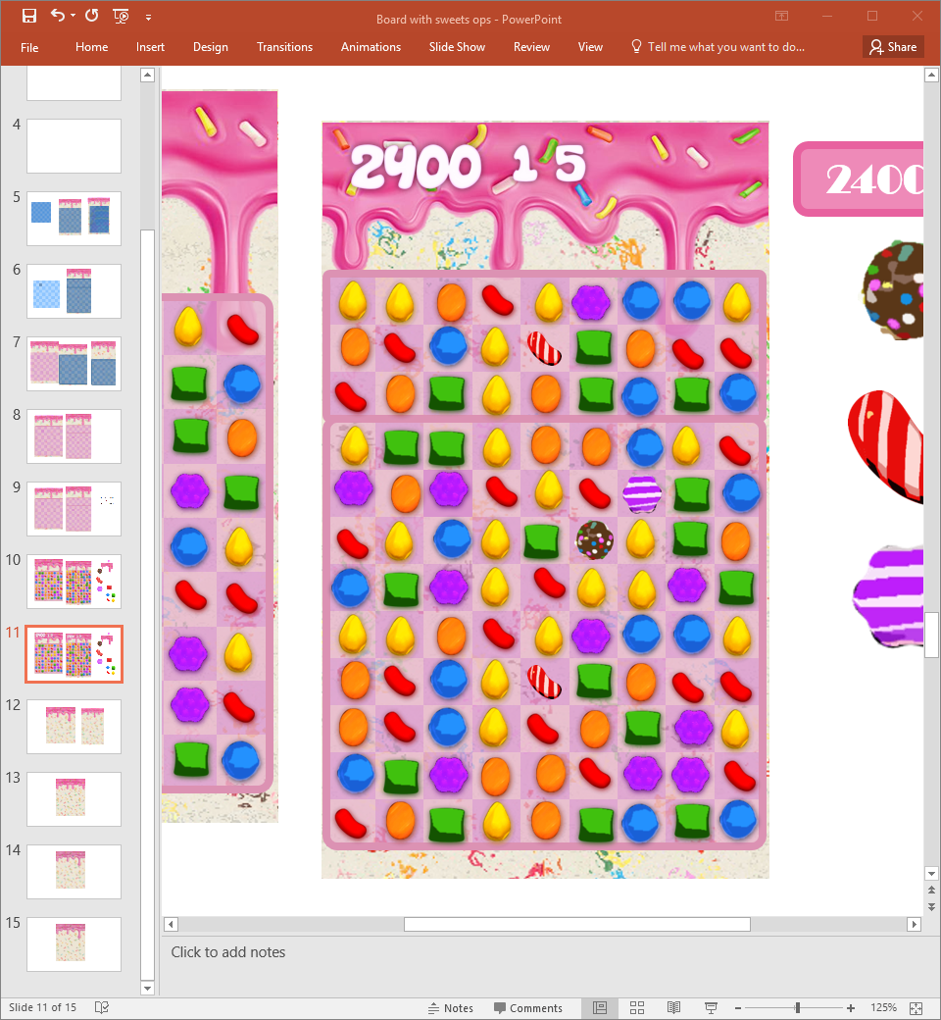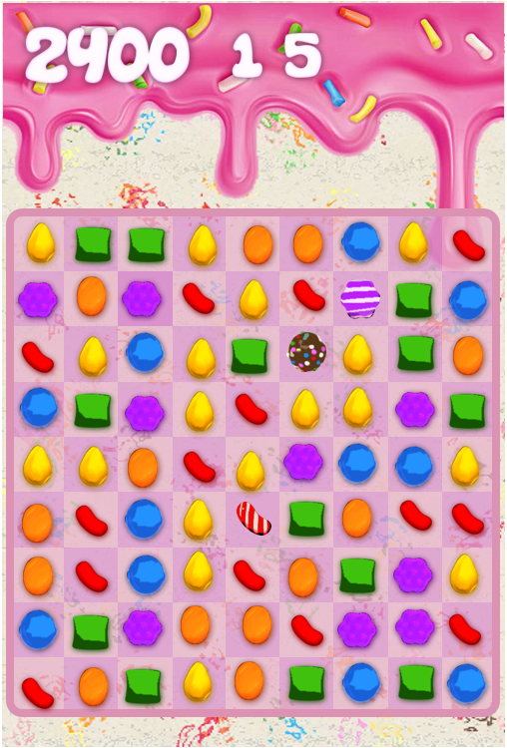

Player Game Screen

Admin Game Screen

### Menu and Board Object Data Tables:

Menu Screen Data Table:

|  |  |  |  |
| --- | --- | --- | --- |
| Object Name | Type | Variable | Other |
| PlayButton | Image | Play Button | May load a different coloured image to show that the button has been clicked |
|  | Rectangle | PlayHitBox  PlayClick = False  XPlay  YPlay  PlayWidth  PlayLeng | The X and Y coordinates are for the top left corner. |
| RulesButton | Image |  |  |
|  | Rectangle | RulesHit Box  RulesClick = False  XRules  YRules  RulesWidth  RulesLeng |  |
| MenuBackground | Image | Loadimage | Background with game title |

Player Game Screen Data Table:

|  |  |  |  |
| --- | --- | --- | --- |
| Object Name | Type | Variable | Other |
| Sweet | class | For each candy:  Image  Hitbox |  |
| Score | Image | PlayerScore |  |
| Moves | Image | MovesLeft |  |
|  |  |  |  |
|  |  |  |  |

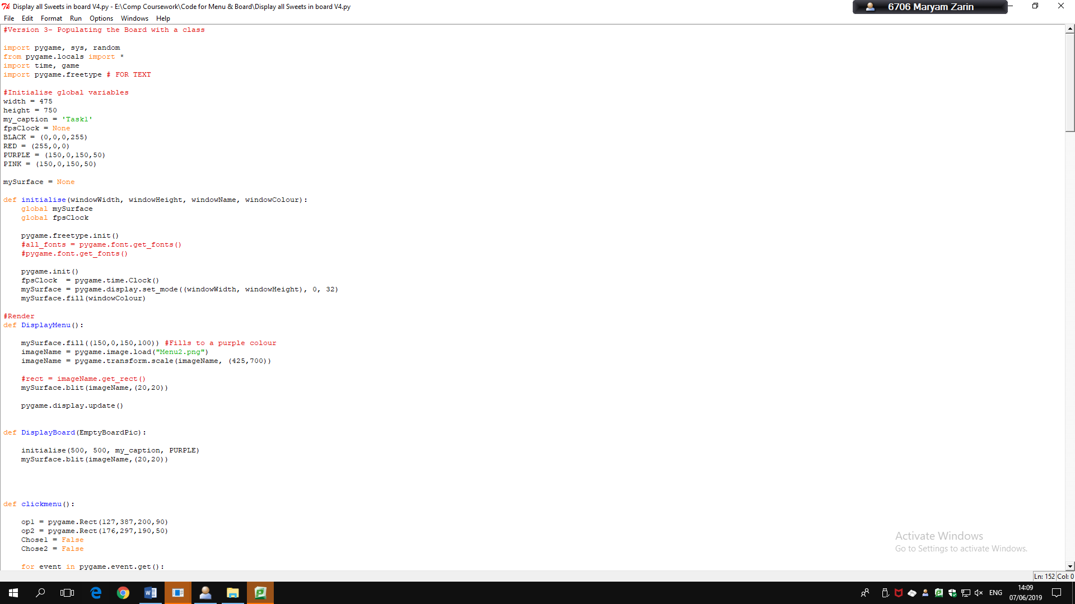

### Code to display the Menu & Board

I have written some code to display the menu and a board of normal sweets to show how similar I can get the coded version to look like the mock ups.

In doing so, I have created a sweet class and an Array of the board which I have populated with Sweet objects, each with their individual characteristics and image which I have blitted to the screen.

For the menu I blit the image of above onto the screen and depending on where the user clicks I display the board. In this version I chose to focus on displaying the board pieces, rather than displaying the rules if they click on Option 2 or the Admin Mode.

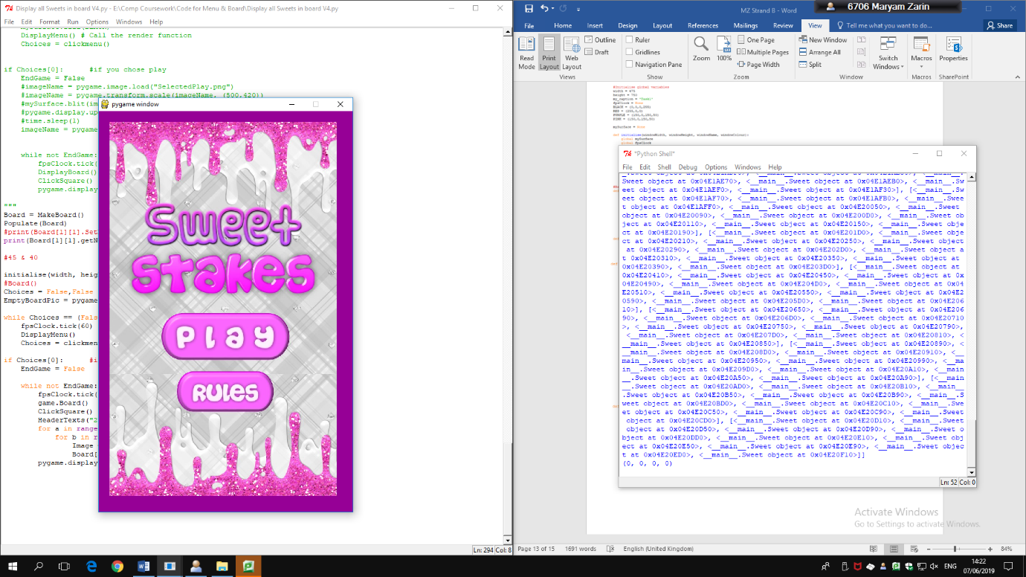

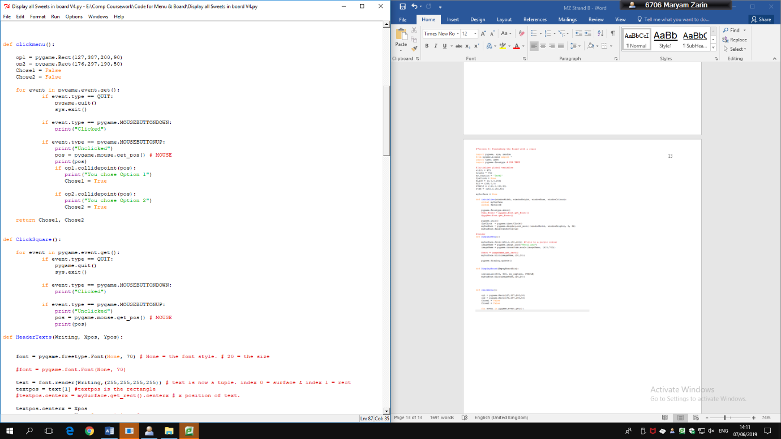

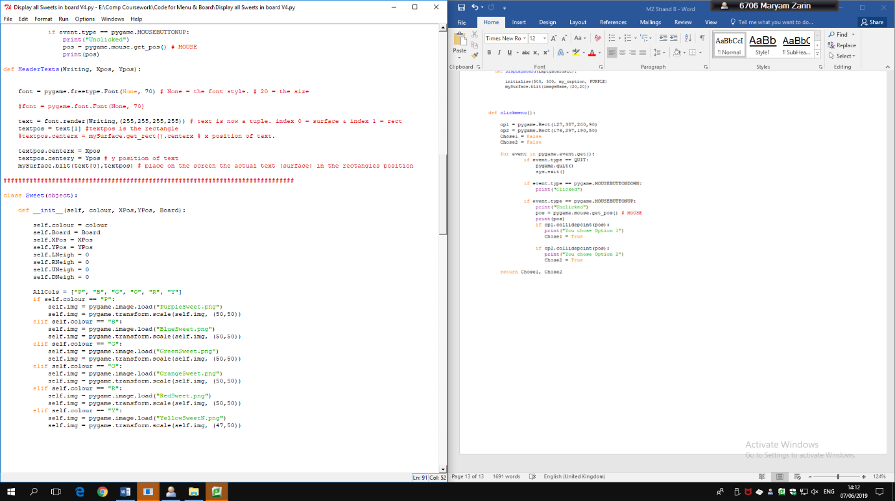

Sweet Class- In the real version I will move this class to a separate file and call it from there

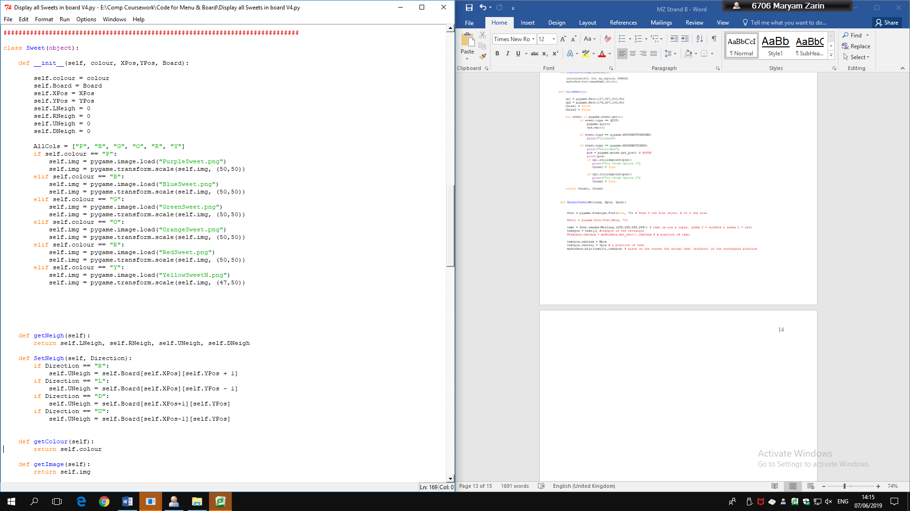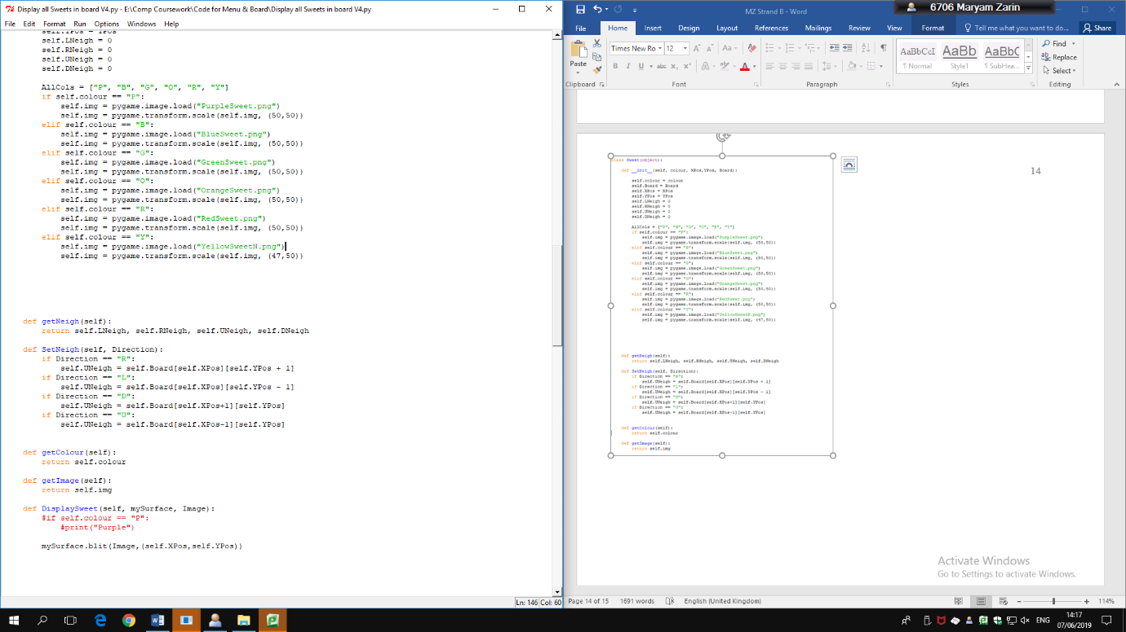

This class creates a sweet object with knowledge of its own colour, X and Y positions, and the neighbours on all sides of it

At the moment all these sweets are plain, so I need to add a Stripes or Wrapped attribute and A multi-coloured sweet option as well as the potential blockers

Would create a class Queue of 9 lists of 3, with functions such as Pop the object from the list (into the board) and Regenerate to keep it full in the initialise function.

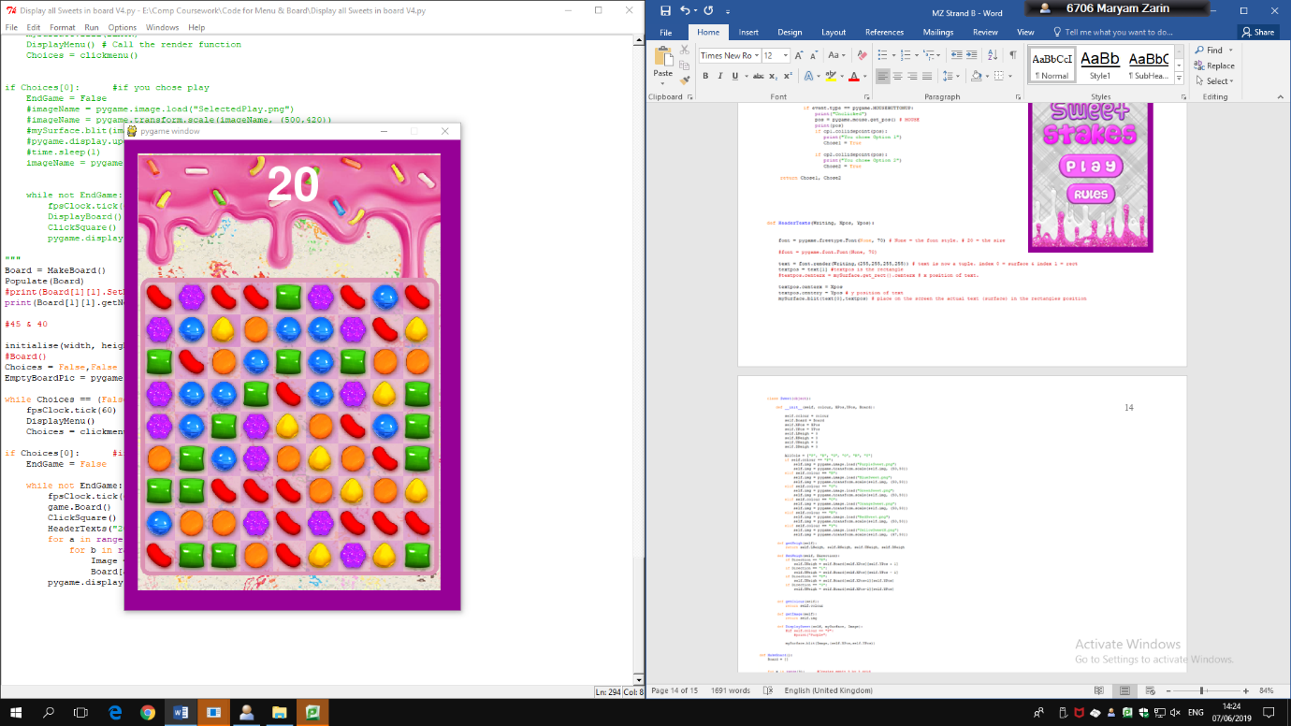

The font for the number of moves and points is different to the Mock Up

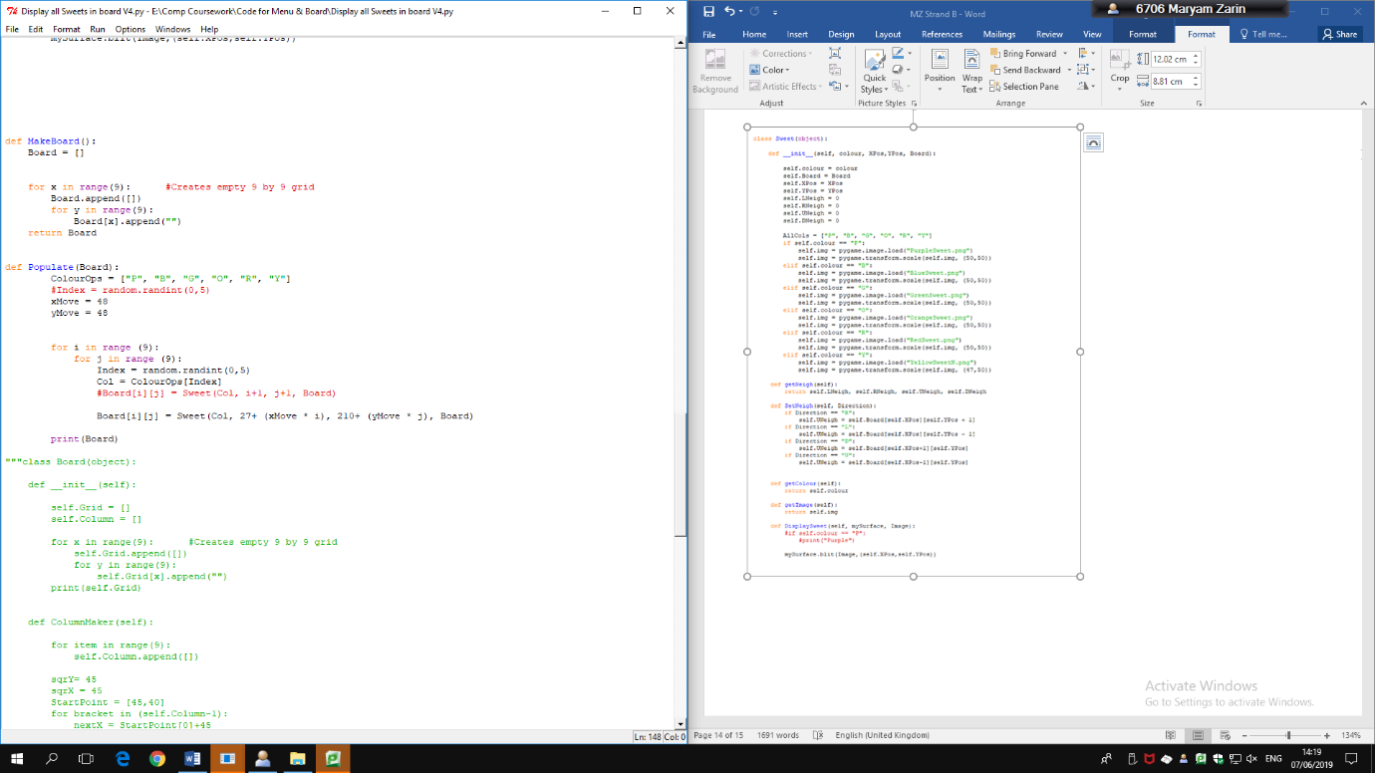

This function creates a 2D 9x9 array for the board

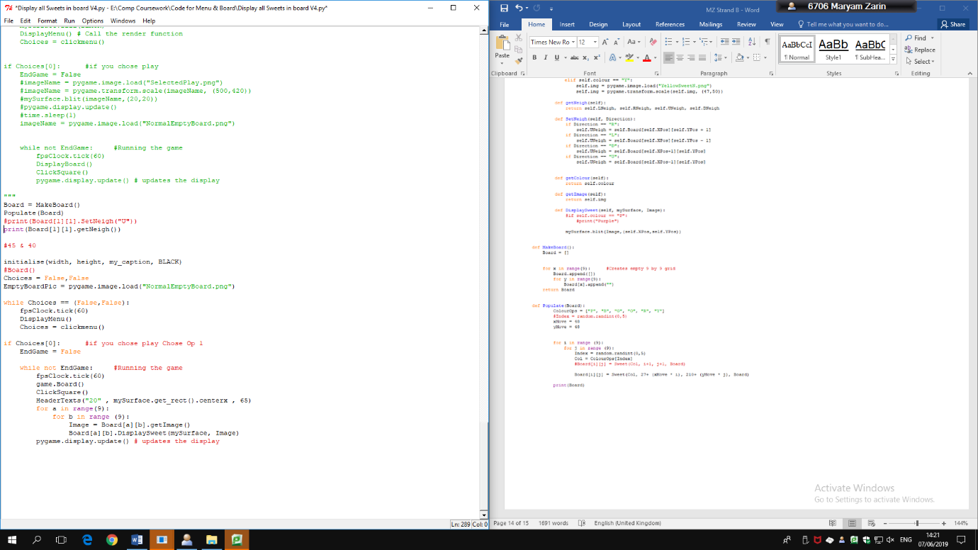

This function populates the board randomly, with Red, Blue, Purple, Green, Orange and Yellow Sweet Objects

I also need to create a function that checks if there is a match between 3 or more sweets so that when the starting board is displayed there aren’t already 3 in a row

This is the main code, which still contains testing lines, the entire game is run within a loop.

## System Flowchart

## Play Game Function Flow Chart

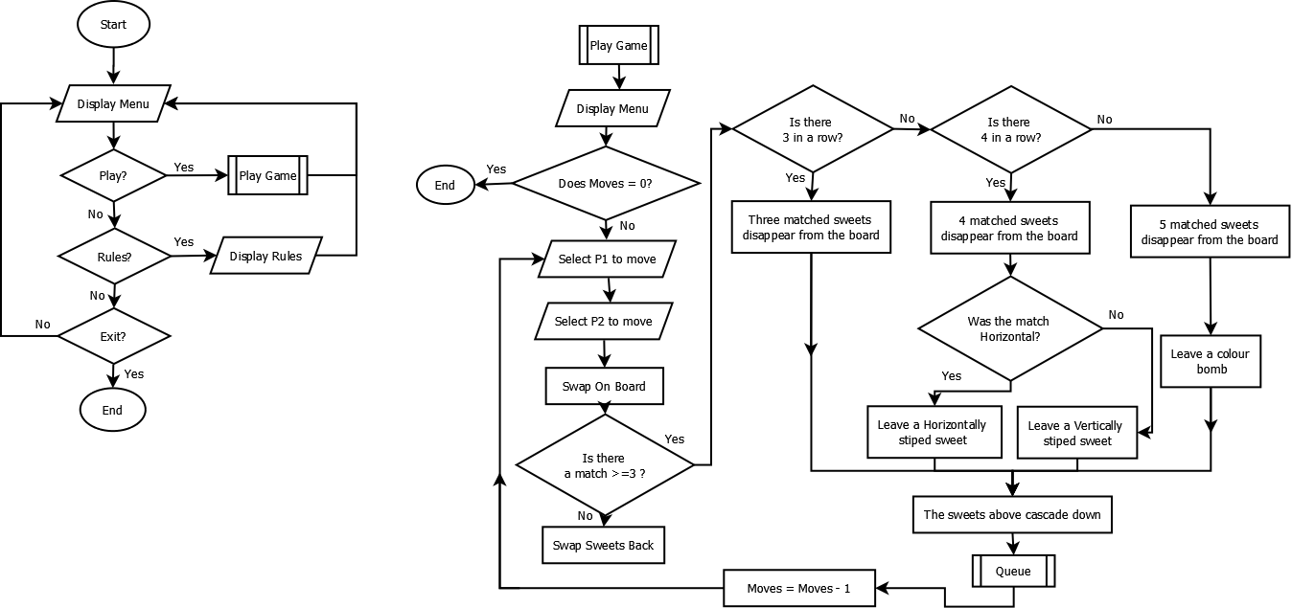

|  |
| --- |
| **Striped (Sweet)** |
| - Stripes : String  - DestroyCondition = String  #All in Row or Column |
| + getStripes : String |

## Sweet Class Diagram

|  |
| --- |
| **Sweet (Object)** |
| - Colour: String  - Board : List  - Xpos : Integer  - Ypos : Integer  - LeftNeigh : Object  - RightNeigh : Object  - UpNeigh : Object  - DownNeigh : Object  -Jelly = Integer |
| + getNeigh : Object  + SetNeigh  + getColour : String  + getImage : Image  + DisplaySweet |

|  |
| --- |
| **ColourBomb (Sweet)** |
| - DestroyCondition = String  # All of 1 colour on the board |
| + |

|  |
| --- |
| **PinkCoconutWheel (Sweet)** |
| - DestroyCondition = String  #Turn 1st 3 sweets in direction swiped into stripes |
| + |

|  |
| --- |
| **Chocolate (Sweet)** |
| - Swipe = False |
| + Grow  #only one chocolate per move or less |

|  |
| --- |
| **Liquorice (Sweet)** |
| - Swipe = False |
| + Match  #Disappears when there is a match in the squares next to |

* *Sweet*
* *Striped, Colour Bomb, Chocolate, Liquorice*

Get at least 2 special sweets working

Code to run board from file for Testing

Preparation for Testing

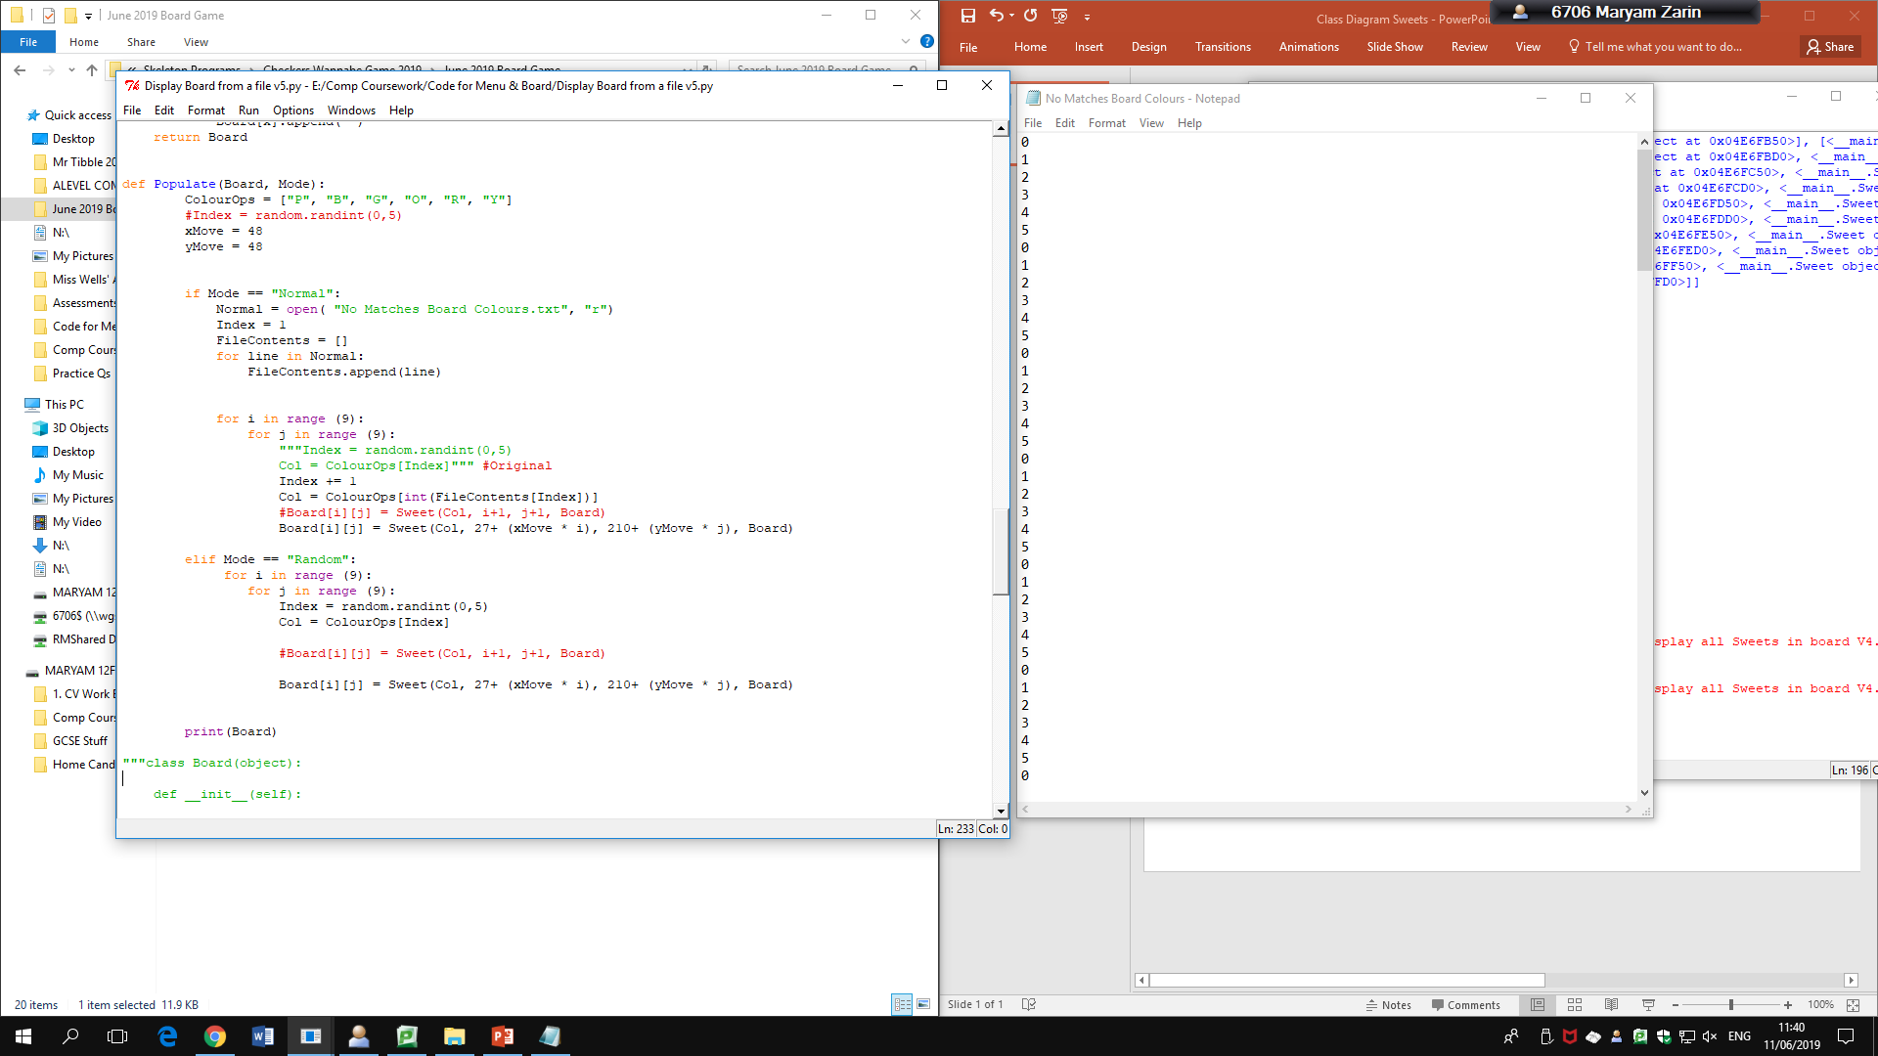

Here, I have written some code to display a fixed board from a text file so that I can test how the code reacts to specific situations.

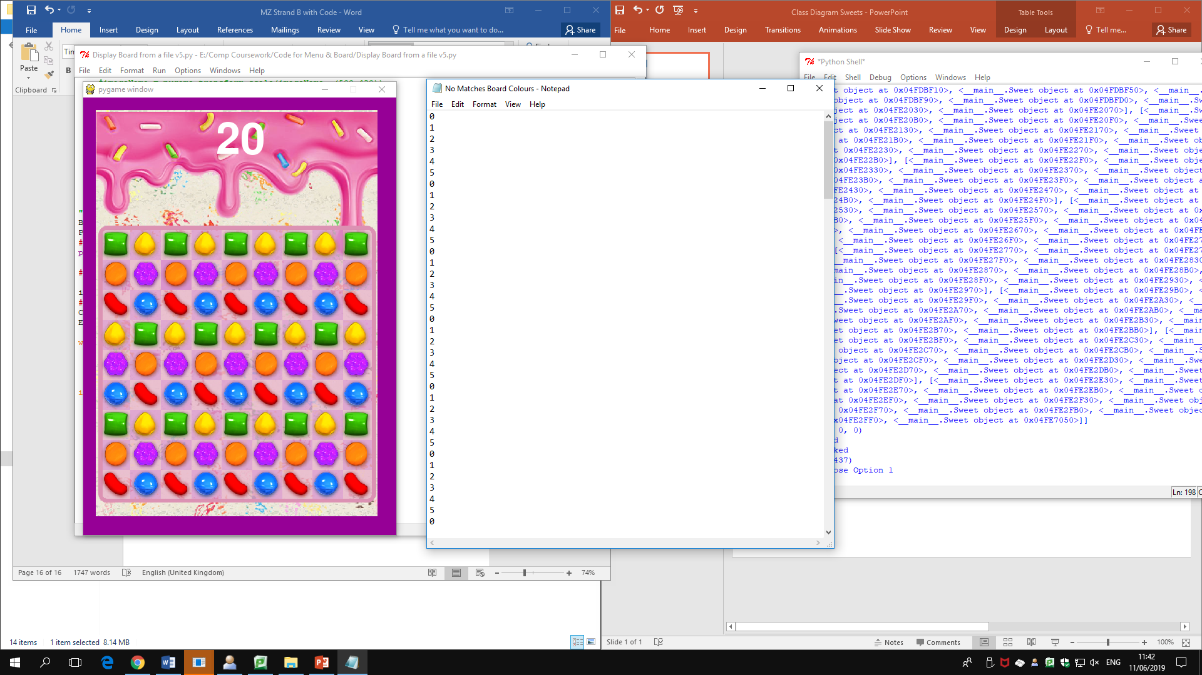

* *System FlowChart*
* *Pseudocode & Variable Tables for some important Functions- Match 3, Fill Board- Queue*
* *Testing Tables- objectives*
* *Big Class Diagram*

Queue = Class with pop and write functions

There are no matches & each number represents a colour from 0-5

There is still the option to run the board in “Random” mode

|  |  |  |  |  |  |
| --- | --- | --- | --- | --- | --- |
| Test Name | Objectives | Test Type | Expected Outcome | Actual Outcome | Comment  + Evidence |
| Menu | Click Play | Valid- Clicking Inside the Box  Boundary- Clicking the edge of the box  Erroneous – Clicking Outside the box | Valid – Show Game Screen  Boundary – Show Game Screen  Erroneous – Nothing, continue displaying the menu | True |  |
| Initial Board | Display a board that has no matches to screen |  | Display Board of sweets, there can be no more than 2 of the same colour sweet next to eachother, Number of points should be 0, all of the sweets should be within their board square | True |  |
| Swiping | Select two sweets, if they don’t form a match in their new position then don’t swap | Valid- Swapping two adjacent sweets to create a match  Boundary- Selecting the square that the sweet is an as opposed to the actual sweet  Erroneous- Swapping two sweets that are a match but not next to each other | Valid- Should swap sweets  Boundary – Should Swap  Erroneous – Should NOT swap | NEED TO FIX |  |
| Matching | If there are 3-5 of the same sweet in a row they should match and disappear |  | Matched Sweets disappear |  |  |
| Filling | After matched sweets disappear the Queue above that column should drop down sweets to fill the blank |  | After a match, the matched sweets disappear and the new sweets enter the board |  |  |
| Match 4 | Leave a striped Sweet |  |  |  |  |
| Match 5 | Leave a Colour Bomb |  |  |  |  |
| Match L | Leave a Wrapped sweet |  |  |  |  |
| Match Striped | Match and gets point for matching an entire Row/Column |  |  |  |  |
| Match Colour Bomb | Match and get points for matching all of the sweets of the same Colour on the Board |  |  |  |  |

Function of Prog

Objectives

* At least 2 types of blockers/ Extra sweets
* Use A class
* The sweets that drop come from a queue
* Swipe 2 sweets- if don’t match return
* Special number of Matches- at least 2 of the 3,4,5 matches should work
* Able to generate a unique board without initial matches every time

Succes Criteria – Swimping Matching

Queues

Return how long the match is

If it was looking right, then now look left and repeat above or if it was looking up, now look down

Keep checking the up or right neighbours until you find one that is no longer the same coulour

If the colour of the new neighbours is the same as the piece that was moved then add 1 to matches

Matches starts off as 0 as none have been found yet

Then saves the coordinates of the 2nd piece so P1 can be put in its place and vice versa

If the X coordinates have not changed then the swap was vertical, else it is a horizontal match

Run Check sides to find out if there are any horizontal or vertical matches once the pieces are in their new places

Match function takes P1 and P2, which are the sweets that the Player has swapped

Pseudocode

Pseudo Match and Check Matches Function

(Assuming P1 is the one for matches & P2 is the other piece)

FUNCTION Match (P1, P2, NeighValue) : Integer, String

Matches = 0

NewXcoord = P2.getXCoord

NewYcoord = P2.getYCoord

IF P1.getXcoord == NewXcoord:

Move = “Vertical”

ELSE:

Move = “Horizontal”

ENDIF

MatchesY = CheckSides(0)

MatchesX = CheckSides(2)

RETURN MatchesX, MatchesY

FUNCTION CheckSides(NeighValue) #Neigh Value would be 0 or 2 for Vertical or horizontal

toCheck = P1.getNeigh()[NeighValue]

IF P1. toCheck.Colour == P1.Colour THEN

Consec = True

CurrentObj = P1

SameY = 1 #Only defined once to add up and down matches

WHILE consec = True:

IF CurrentObj. toCheck.Colour = CurrentObj.Colour THEN

SameY+= 1

CurrentObj = CurrentObj. toCheck

ELSE:

Consec = False

ENDIF

ENDWHILE

ENDIF

toCheck2 = P1.getNeigh()[NeighValue+1] #If NeighValue= 1 then itll check the L or R

IF P1. toCheck.Colour == P1.Colour THEN

Consec = True

CurrentObj = P1

WHILE consec = True:

IF CurrentObj. toCheck.Colour = CurrentObj.Colour THEN

SameY+= 1

CurrentObj = CurrentObj. toCheck

ELSE:

Consec = False

ENDIF

ENDWHILE

ENDIF

RETURN SameY

#In actual code call this function x2 to check matches for each piece

Pseudo For Queue Functions

(Assuming P1 is the one for matches & P2 is the other piece)

FUNCTION EnQueue (P1, P2, NeighValue) : Integer,

CONST MaxSize = 9

VAR CurrentSize = 0

Front = 0

Rear = -1

Q = [0,0,0, 0,0,0, 0,0,0]

#In actual code call this function x2 to check matches for each piece

Code Log

V7 – Select P1 & P2 19/07/19

At this point, the Code successfully:

* Displays the Menu
* Displays a board populated with sweets to the screen
* The sweets are class objects and also
* Display invisible hit boxes so when the user clicks and swipes the Clicksquare function can determine which sweets have been selected.

Following my flow chart I have created the Select P1 and Select P2 functions and now need to :

* Make them move across the screen
* It also needs to check that the sweets selected are neighbours.

V8 – Make pieces move

* My code now allows me to move two pieces successfully! You can see the pieces swap on the board although they just appear after you’ve swapped them and you can swap two pieces from across the board.
* I also made the number of moves countdown.
* Next I need to change the random function so that there aren’t any matches in the initial board.

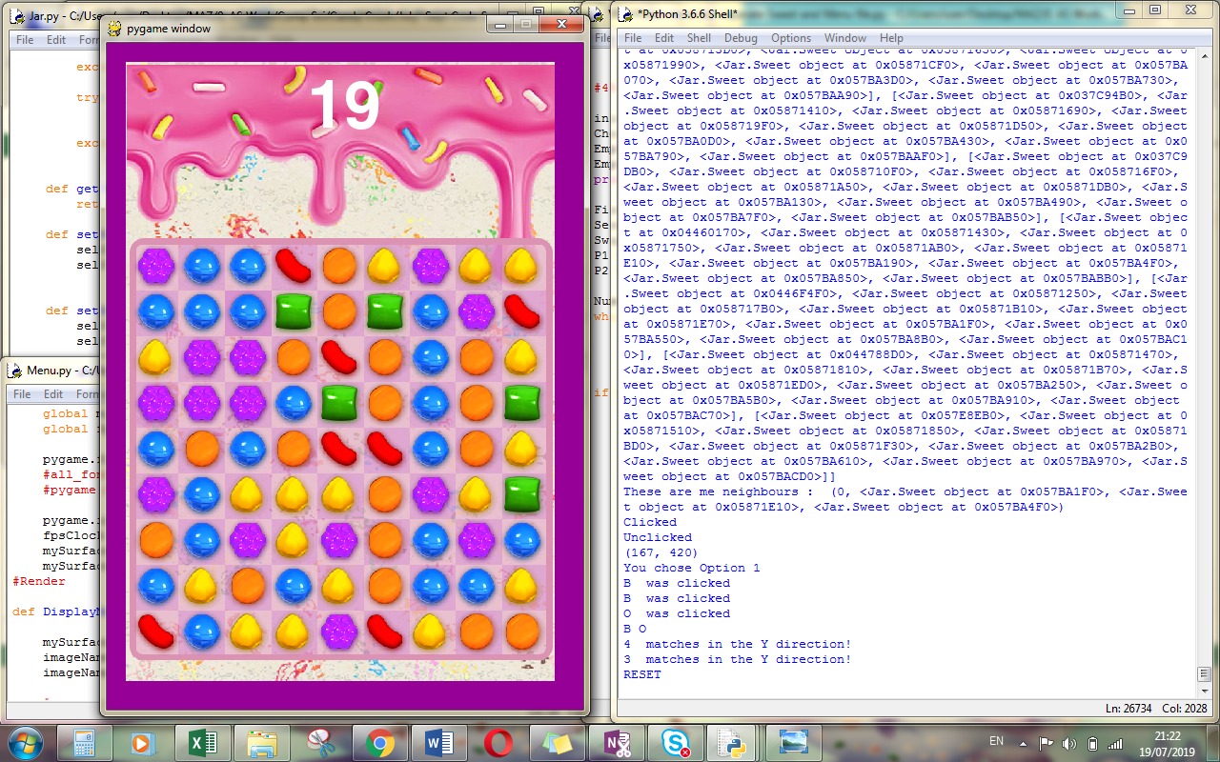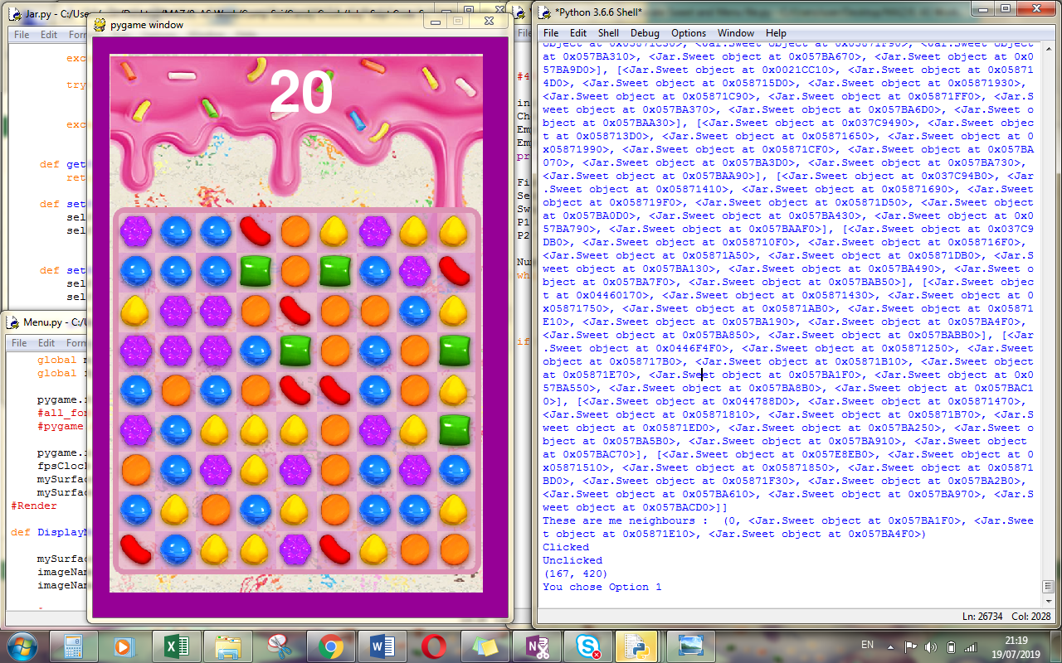

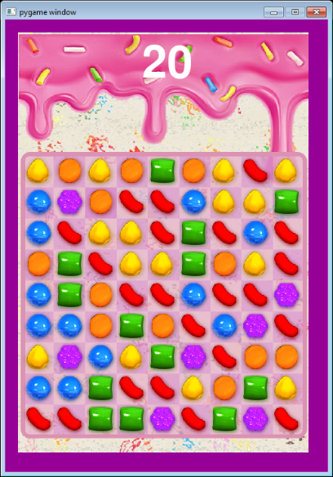

V9 – Generate Board with no Matches

* I have used a series of for loops and my match function to check if there are any matches and generate a board with no matches bigger than 2.
* I have also separated my class into a separate file and taken my DisplayMenu function into another file
* I now need to create a Queue with Pop functions so I can
* Make any matched candies disappear and
* Be replaced with the ones above them in the queue

V15 – When background Matches are bigger than 3 in length need to leave the appropriate special sweet

* Leaves Striped sweets when there is a 4 match in the background
* Leaves a colourbomb when 5 match
* Make any matched candies disappear and
* Be replaced with the ones above them in the queue

Testing